

7,789_Programming with Advanced Computer Languages

CodingXCamp: Group Project



**Prospera: Virtual financial advisor & dashboard**

*Investing can be challenging for those with little financial knowledge. Our program helps users invest based on their initial amount, monthly savings, time horizon and risk appetite. After gathering this information, Prospera, our virtual financial advisor, proposes several investment options for each selected risk level. Users can compare these options using a dynamic dashboard of relevant metrics, choose their preferred ones, and see potential returns based on their inputs. To make technical terms and best practices easier to understand, each window includes “i”-sections containing a brief explanation to help users build financial knowledge.*

Prof. Mario Silic

20 December 2024

Group ID: 3354

Project language: Python

Besmir Kadrii (19-660-216) - besmir

Federico Martelli (23-601-545) – Felide

Nicolas Goumaz (20-616-470) – NicoG

Link to the GitHub page: <https://github.com/malloc37/hsg-finance-dashboard>

**Prospera - Tool overview**

The process flows from user inputs to total monetary return, through a dashboard containing all relevant metrics to navigate and evaluate each financial options within each risk level selected.

**1. Input Interface (Figure 2)**

The user inputs 5 parameters by answering to 5 questions in this sequence:

1. "How much are you looking to invest?" *User to input starting capital for market investments. The initial investment must be greater than zero, otherwise system returns an error message.*
2. "What amount of your monthly savings do you plan to allocate to market investments?" *User to input monthly recurring contribution for market investments*. *The month contribution must be greater than zero, otherwise system returns an error message.*
3. "When do you plan to cash out and enjoy your wealth?" *User to input time horizon for the investment*. *The investment period must be greater than zero, otherwise system returns an error message.*
4. "At which risk levels would you like to invest?" *User to select up to 3 risk levels out of 5 available. If the user selects 0 or more than 3 risk levels, the system returns an error message.*
5. "Please allocate the investment amount in percentages across the selected risk levels" *User to allocate the investment amount in percentages across the risk levels selected. The total allocation across selected risk levels must be exactly 100%, with each chosen level assigned at least 1%, otherwise system returns an error message.*

**2. Mapping of available options**

* **Risk levels**: 5 available; user can select up to 3.
* **Asset options**: Each selected risk level offers 7 selected financial asset options.
* **Maximum selection:** If 3 risk levels selected, then user explores 21 financial assets and choose 1 per risk level.
* **Metrics displayed in dashboard**: Each asset includes 9 tailored pieces of information.
  + **Example**: Risk level 4 includes Bitcoin, and its dashboard displays short description, price history, annualized return, market cap, volatility, circulating supply, 24-hour volume, sustainability metrics, news sentiment.
* **The data is dynamically retrieved from Yahoo Finance**. It can happen that some data is sometimes not available for certain investment options.

**3. Dashboard interface (Figure 3)**

Once the desired risk levels (input iv) are selected, the dashboard serves as a focused visualization of all the metrics needed to evaluate the financial instruments that best align with the chosen risks. Complex metrics include an (i)-section with explanations on how to interpret and use them effectively.

**4. Lateral menu (Figure 4)**

The lateral menu enables user-friendly navigation between inputs, allowing modifications to all inputs except input iv (risk level selection). Changing input iv requires returning to the Input Interface section. This deliberate design choice reflects the rationale that risk level selection defines the framework for other inputs. Therefore, risk level selection must precede the other inputs - initial investment, monthly recurring contribution, investment timeframe, and split percentages across selected risk levels -, and must be modified with greater caution by the user.

**5. Output Interface (Figure 6)**

Once an asset is selected for each previously chosen risk level and “Show expected returns” button is clicked within the “Selection of assets” box (Figure 5), the system calculates the forecasted average return rates (CAGR & ROR), the average investment risk, and the expected total monetary return, based on the provided inputs and chosen assets.

**6. Overview through Data flow and User interaction diagram**

Figure 1: Data flow and User interaction diagram.

7. Code-related information

Double Click for security reasons: All actions required to proceed to the next page interface demand a double click instead of a single click to trigger properly. We conceived this as a security measure to draw the investor's attention to their financial decisions.

Please look at the GitHub page (<https://github.com/malloc37/hsg-finance-dashboard>) for information on how to install and run the dashboard, and information about the project features and structure.

Appendix – Collection of Prospera screenshots

This appendix provides a collection of screenshots from Prospera - our financial advisor tool - to aid understanding of the above description.

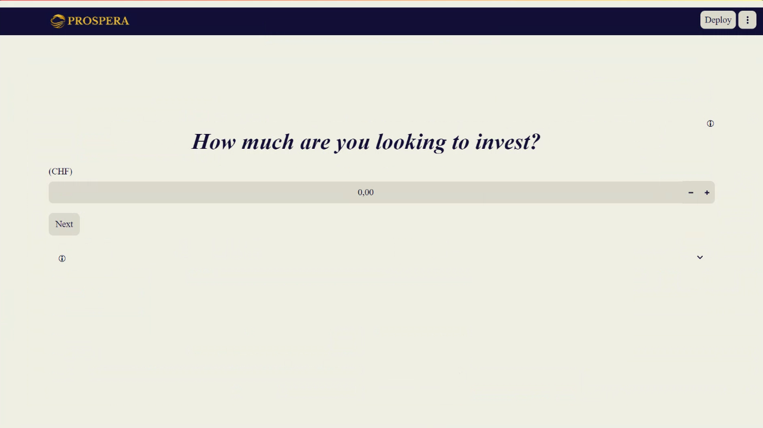

Figure 2: Input interface with 1st question.

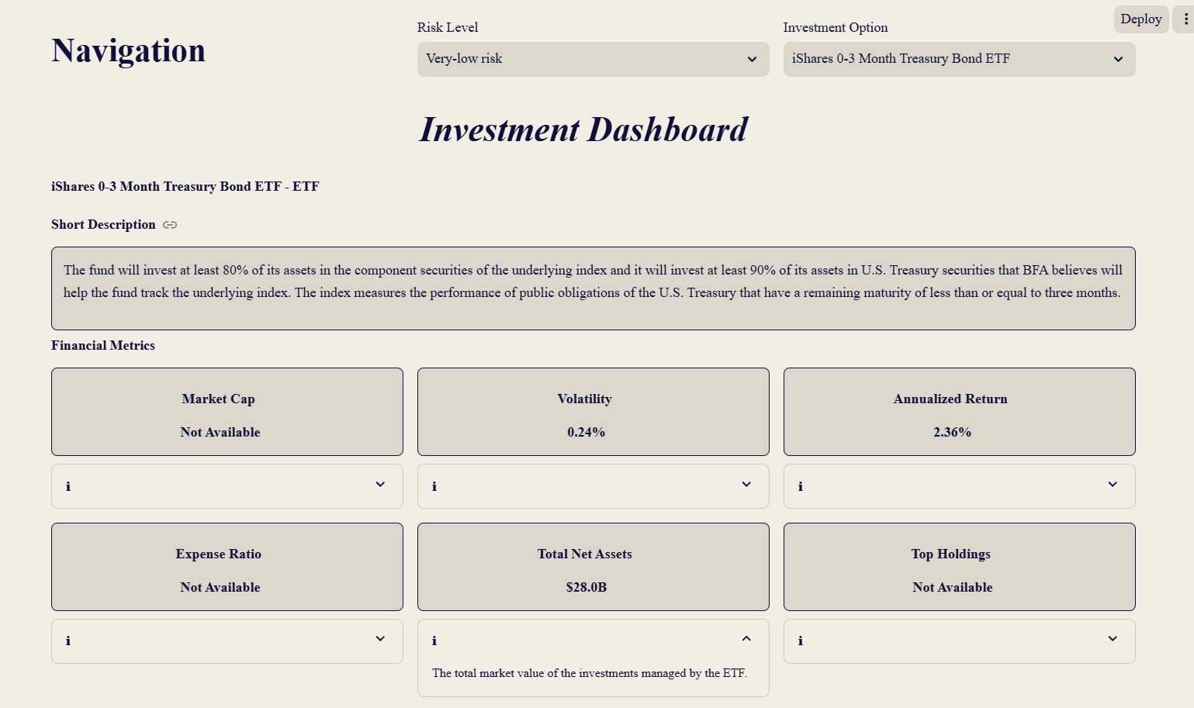

Figure 3: Dashboard with all relevant metrics.

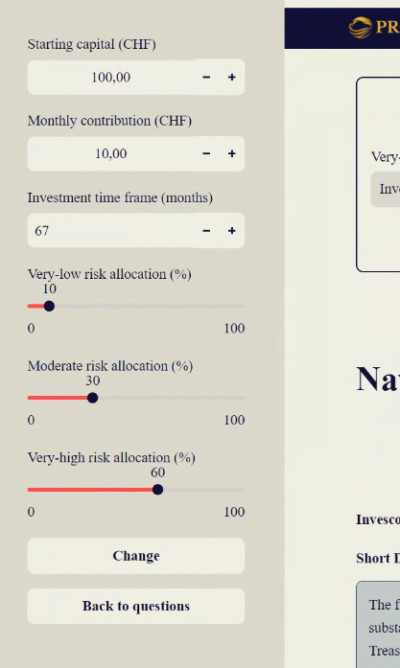

Figure 4: Lateral menu to change initial inputs (excl. risk levels).

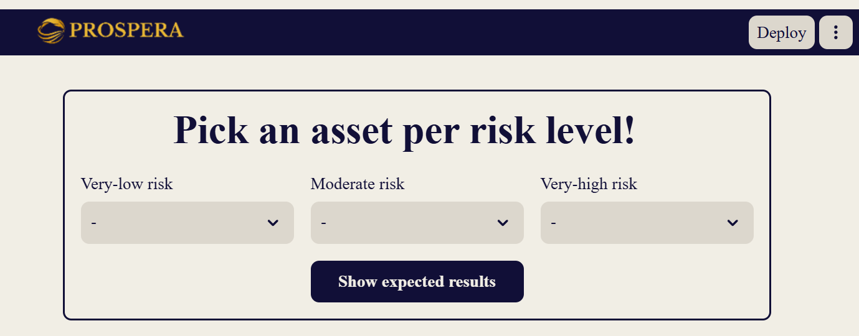

Figure 5: Selection of assets to proceed to the return outputs interface.

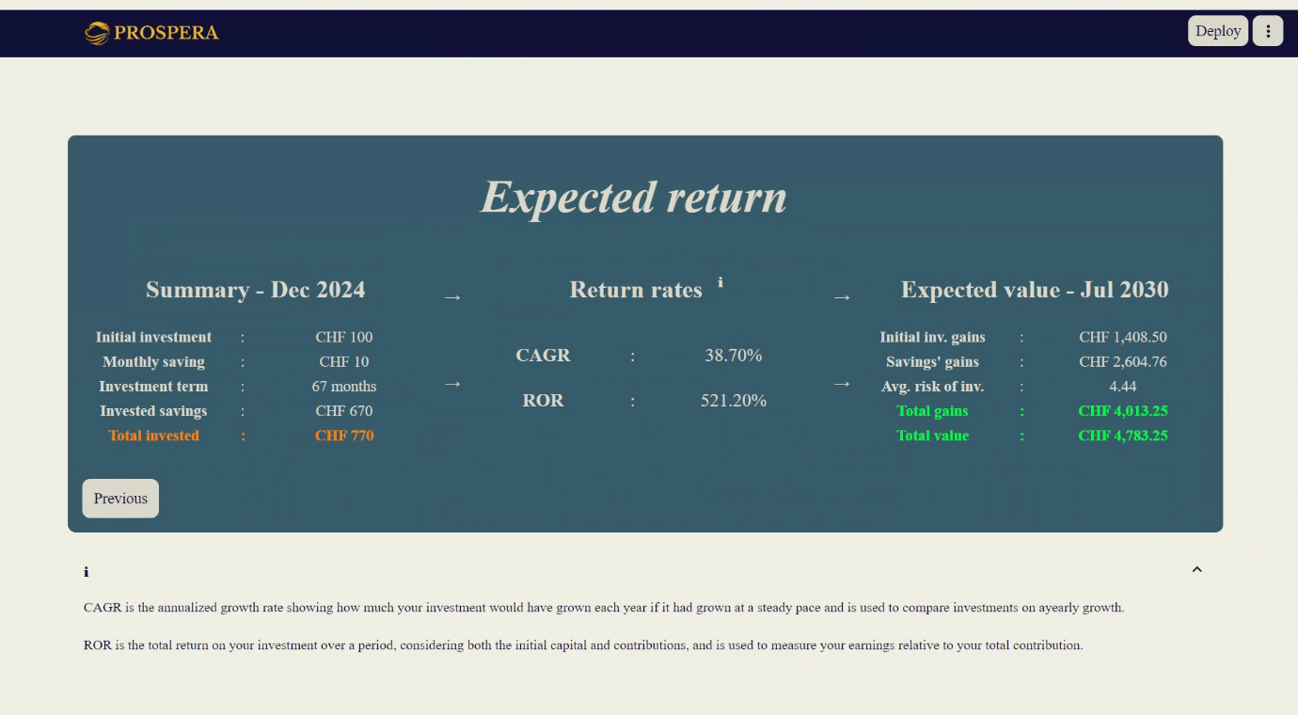

Figure 6: Output interface with all predicted returns.